- Colonoscopy examination allows the doctor to visually examine the lining of the colon for abnormalities such as polyps, inflammation or malignancy.
- Colonoscopy is typically done as an outpatient with the use of intravenous sedation, provided by an anesthesiologist/anesthetist. A driver is needed to return you home.
- Colonoscopy is considered a low risk procedure. The benefits include early diagnosis and prevention of colon cancer. The risks and benefits of colonoscopy will be discussed with you before the procedure.
Preparation
- Aspirin can be continued through the colonoscopy, if there is a history of coronary disease or stroke.
- If you take blood thinners other than aspirin (like coumadin/warfarin, Plavix/clopidogrel, Xarelto or Eliquis) please discuss this with your prescribing provider. A written instruction is generally needed to proceed.
- Blood pressure and cardiac medications must be taken at their usual time with a sip of water.
- Diabetes oral medications are held the night before and the morning of the colonoscopy.
Insulin is generally taken in half dose the night before and held in the morning of colonoscopy.
Please discuss management of your diabetes with your primary care or diabetes provider.
- Please notify the office if constipation is an issue for you. You may be asked to take additional laxatives the week leading up to colonoscopy

1 WEEK BEFORE COLONOSCOPY:
- Avoid high-fiber foods for the week. Try to avoid nuts seeds and corn, cruciferous vegetables, bran, whole-grains, fresh or whole fruit, or beans. Stop fiber supplements like Citrucel, Metamucil (psyllium), fibercon.
- Eat a Low fiber diet, for last 3 days before colonoscopy , includes white bread, cottage cheese, yogurt, lettuce, cooked vegetables without pulp . A diet which is higher in protein, such as eggs, meat, fish is low in fiber, and a good choice.

Purchase these supplies from your local pharmacy, they are available without prescription.
- MiraLAX: 3 bottles of 119 gm each bottle
- Dulcolax (bisacodyl), 5 mg tablets, 4 pills.
- Gatorade (You may also use Pedialyte or coconut water) three 28 ounce bottles. Avoid the red.
- Simethicone or Gas-X tablets, 4 pills, 80 mg.

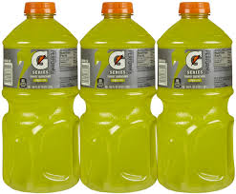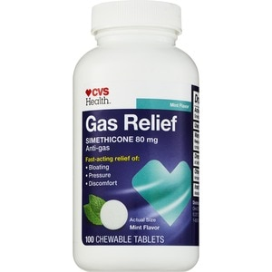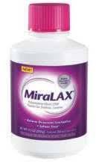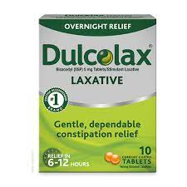

THE MORNING BEFORE COLONOSCOPY
- Drink only clear liquids for breakfast, lunch and dinner the day before colonoscopy.
(Clear liquid diet includes coffee or tea without creamer, clear fruit juices, plain gelatin or Jell-O, water, chicken broth, clear soda or ice pops. Avoid red color.)

THE AFTERNOON BEFORE COLONOSCOPY at 4 PM
- Mix MiraLAX bottle (119 gm.) with 28 ounces of liquid ( Gatorade or Pedialyte or coconut water). Keep refrigerated.
- Take the 4 Dulcolax/bisacodyl pills at 4 PM.
- Start drinking the Miralax solution at 4 PM. Try to drink an 8 ounce serving of the solution every 15 minutes. If you feel bloated, slow the process.

THE EVENING BEFORE COLONOSCOPY at 6 PM
- Mix MiraLAX bottle (119 gm.) with 28 ounces of liquid ( Gatorade or Pedialyte or coconut water). Keep refrigerated.
- 7 PM on the night before colonoscopy, start drinking the second dose of MiraLAX solution. Try to drink an 8 ounce serving of the solution every 15 minutes.
- If you feel bloated you can slow the process.
THE DAY OF COLONOSCOPY
- Take all blood pressure and cardiac medications at their usual times.
- Mix MiraLAX bottle (119 gm.) with 28 ounces of liquid (Gatorade or Pedialyte or coconut water). Keep refrigerated.
DRINK the 3rd and last dose of solution the morning before colonoscopy
- 6 hours before your arrival time start drinking the MiraLAX solution. Drink 8 ounces of MiraLAX solution every 15 minutes.
- Take the four Gas-X or simethicone tablets 2 hours before the colonoscopy with sip of water.
- You must complete drinking the remaining solution 2 hours before the procedure time.
- NOTHING by mouth for 2 hours before your procedure. You can take blood pressure or cardiac medications with a sip of water at their usual times.

If you have been immunized against SARS COV 2 infection please bring your immunization record.

- You are scheduled for a colonoscopy on:

________ day, ___ / ___ / ___ at _____ AM/PM

@ Surgery Center of Hamilton (1445 Whitehorse Mercerville Rd) OR Regional Medical Center (Trenton)

Report/ biopsy results will appear on the Lawrence Gastro patient portal 2 weeks after your procedure.

If at any time before or after the procedure you develop severe abdominal pain, fever or bleeding, call the office as soon as possible.

